|  |  |  |  |
| --- | --- | --- | --- |
| X | 0 | 1 | 3 |
| F(x) | 1 | 3 | 2 |

**Input:**

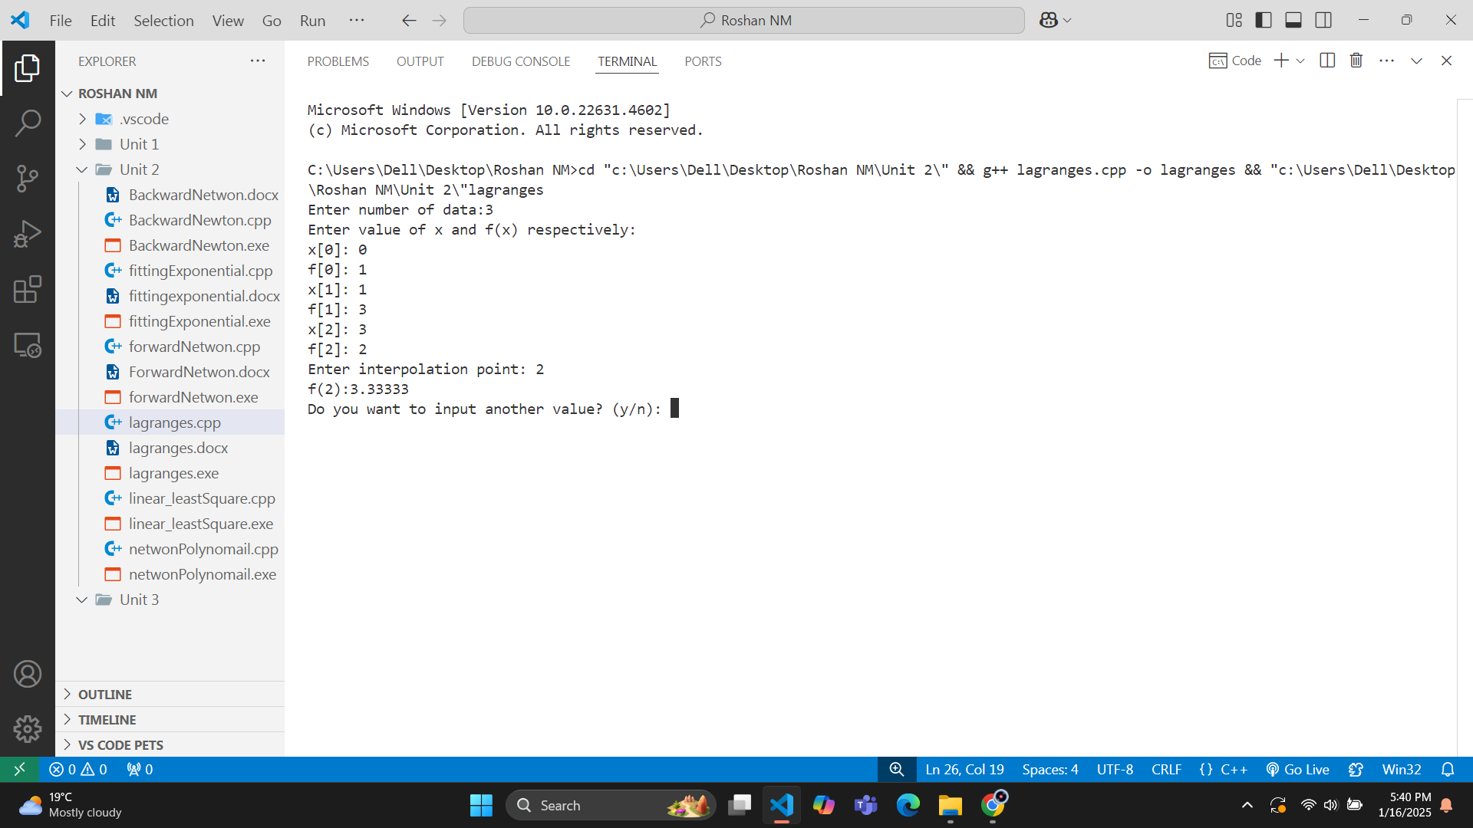**Output:**

|  |  |  |  |
| --- | --- | --- | --- |
| X | 0.3333 | 0.25 | 1 |
| F(x) | 2 | -1 | 7 |

**Input:**

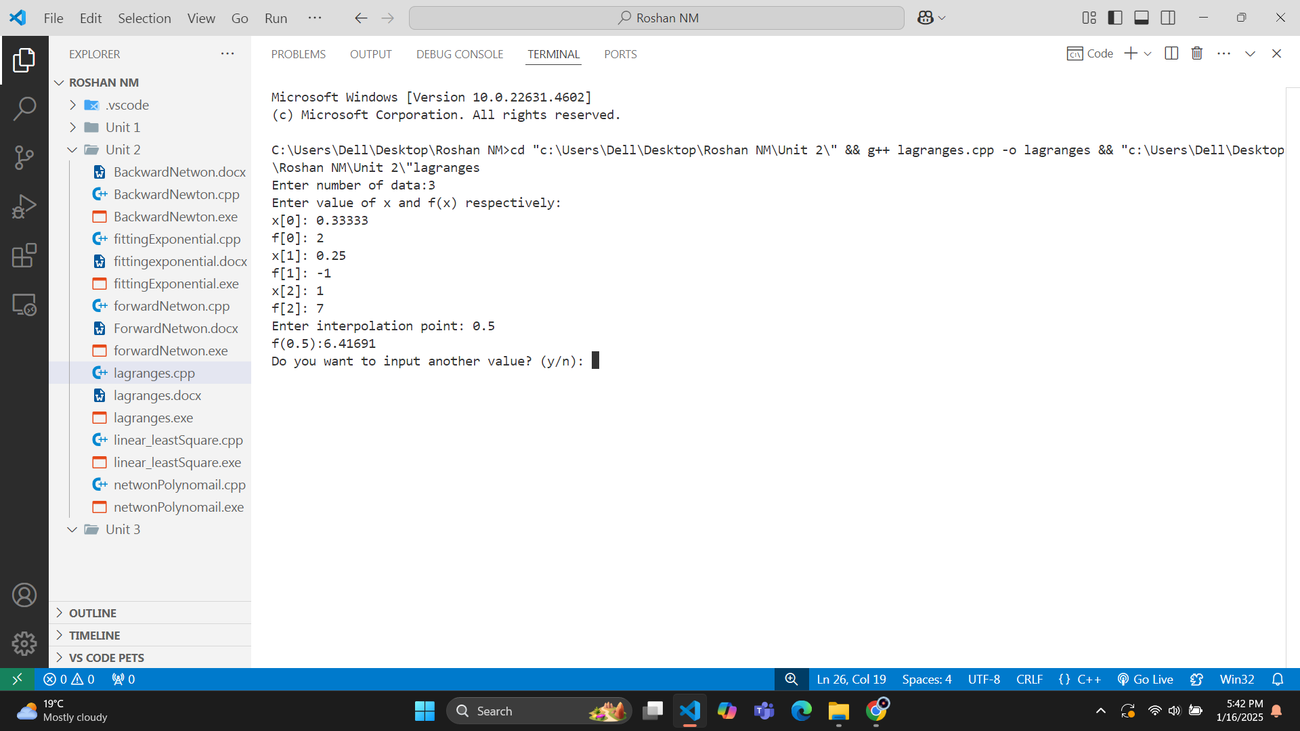**Output:**